Embargoed until 24 April 2018

All Aboard! Sennheiser supplies wireless Digital 6000 Microphones to Eurovision Song Contest

Wedemark/Lisbon, 24 April, 2018 – As a technical supplier to the 2018 Eurovision Song Contest in Lisbon, audio specialist Sennheiser and its local partner Magnelusa have supplied Digital 6000 wireless microphones and 2000 series wireless monitors to the world’s largest live music event, hosted by Rádio e Televisão de Portugal (RTP). With rehearsals ongoing since 22 April, the equipment is already in heavy use in Lisbon’s Altice Arena and the ESC press centre.

With 43 participating nations, the 63rd Eurovision Song Contest will feature live broadcasts of the two semi-finals on 8 and 10 May and the grand finale on 12 May. All artists will rely on Digital 6000 microphones, and use either SKM 6000 handhelds with MD 9235 dynamic capsules, or SK 6000 bodypacks with Sennheiser custom headmics. For wireless monitoring, 2000 series systems will be on duty: Rack-mount SR 2050 IEM two-channel transmitters transmit their signals via A 5000-CP circularly polarised antennas to the artists’ EK 2000 IEM bodypack receivers. A large number of bodypacks ensures that all artist groups and the technical crew can be provided with high-quality audio signals.

 | Audio specialist Sennheiser provides wireless microphones and monitors plus technical support to the Eurovision Song Contest, the world’s largest live music event.
On-site technical support
Volker Schmitt, Director Customer Development & Application Engineering at Sennheiser, and his team will be on site to provide technical support for the wireless systems: “We are excited to be technical suppliers to the ESC, the world’s largest live music broadcast, and very much look forward to working with Daniel Bekerman, the Head of Sound for this magnificent series of live shows.”

Backstage communications with Command function
For backstage communications, the new Command function of the 6000 series is being used to enable the ESC’s technical team to establish talkback links, for example for the stage director or the liaison manager. For this, the crew uses special SKM 9000 COM handheld transmitters or SK 6000 bodypack transmitters that have been Command-enabled via the KA 9000 COM Command switch.

The Command function of Digital 6000 allows the technical team to program any output as their talkback channel and choose push-to-talk or push-to-mute modes. The receiver display provides current information on the output status. | 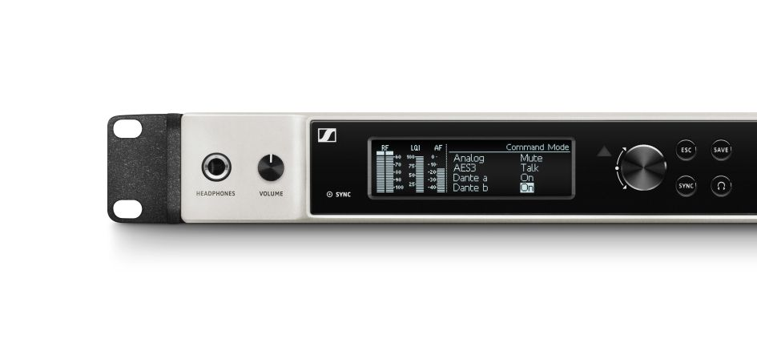
Digital 6000 microphones are also used in the press centre, where conferences and Q&A sessions make use of EM 6000 receivers and SKM 6000 handhelds with Neumann cardioid KK 204 condenser microphone heads.

Volker Schmitt: “Altogether, more than 100 wireless channels will be in use for audio alone. This will be an ideal environment for Digital 6000 to demonstrate its spectrum efficiency. As the system has been designed to be intermodulation-free, we can arrange its transmission frequencies in an equidistant grid, saving spectrum for other wireless applications.”

Sennheiser equipment on site
- 41 EM 6000 two-channel receivers
- 74 SK 6000 bodypack transmitters
- 68 SKM 6000 handheld transmitters, with MD 9235 capsules for the artists and KK 204 capsules for communication purposes
- 115 custom Sennheiser headmics
- 6 SKM 9000 COM handheld transmitters
- 6 KA 9000 COM Command switches
- 21 L 6000 rack-mount charging units with chargers for SK 6000 and SKM 6000/9000
- 17 SR 2050 IEM two-channel transmitters
- 112 EK 2000 IEM bodypack receivers

Useful links:
https://eurovision.tv/ - The official website of the Eurovision Song Contest

About Sennheiser
Sennheiser is shaping the future of audio – a vision built on more than 70 years of innovation culture, which is deeply rooted within the family-owned company. Founded in 1945, Sennheiser is one of the world’s leading manufacturers of headphones, microphones and wireless transmission systems. With 20 sales subsidiaries and long-established trading partners, the company is active in more than 50 countries and operates its own production facilities in Germany, Ireland and the USA. Sennheiser has around 2,800 employees around the world that share a passion for audio excellence. Since 2013, Sennheiser has been managed by Daniel Sennheiser and Dr. Andreas Sennheiser, the third generation of the family to run the company. In 2016, the Sennheiser Group had sales totalling €658.4 million. www.sennheiser.com

Local Contact Global Press Contact

Francisco Abadia Stephanie Schmidt
fabadia@magnelusa.pt stephanie.schmidt@sennheiser.com
M (+351) 917 611 829 T +49 (5130) 600 – 1275

